# 

# **Weight Watcher2 Demo**

Stateless CEP Decision Service Use Case

For OpenShift Origin Vagrant VM

and JBoss Drools 6.3.0.FINAL

as tested on OS/X El Capitan



Stefano Picozzi

Sydney, Australia

[spicozzi@emergitect.com](mailto:spicozzi@emergitect.com)

<http://blog.emergile.com>

# Table of Contents

Table of Contents 2

1 Introduction 3

1.1 Overview 3

1.2 Learning Goals 4

1.3 Prerequisites 4

2 Setup OpenShift 3 5

2.1 For OpenShift Origin Vagrant VM 5

2.2 For Existing OpenShift System 5

2.3 dnsmasq Install 6

2.4 OpenShift Origin Vagrant Install 7

2.5 OpenShift Origin Vagrant Final Preparation Steps 8

3 Setup Demonstration Applications 9

3.1 Environment Checklist 9

3.2 Demo Setup as OpenShift root User 10

4 Standard Use Cases 11

4.1 OpenShift Developer Console Tour 11

4.2 Docker Image to Create Decision Service 12

4.3 Source To Image to Create Companion Website 13

4.4 Drools Workbench Tour 15

4.5 SoapUI Samples 17

4.6 R using RStudio 18

5 Advanced Use Cases 20

5.1 MySQL with Persistent Storage 20

5.2 Rule Changes using oc rsync 21

5.2.1 Start the Decision Service Scanner 21

5.2.2 Rule Changes using Workbench 22

5.2.3 Apply Rule Changes to the Decision Service 22

6 Extras 23

6.1 Image Download 23

6.2 Source Download 23

6.3 Launch Container Instances using Docker Toolbox 24

6.4 Useful (Docker Toolbox) Docker Commands 25

6.5 Useful OpenShift Commands 26

6.6 Useful Vagrant Commands 27

6.7 Changing Rules Docker Toolbox example 28

6.8 Quick Restart Checklist 29

7 Enhancements 30

7.1 To Do 30

8 Draft Working Notes 31

8.1 Binary war deployment 31

8.2 Another php client 31

# Introduction

## Overview

Interested in a demo that gets you started with OpenShift and showcases the Drools (6.3.0.FINAL) Decision Service?* Then look here. The application is a stateless Decision Service with complex event processing (CEP) support based on a pseudo clock.

An example use case demonstrated includes a (REST) client sending a time series of *facts* in the form of weight observations to the Decision Service. The Decision Service then reasons over the inputs to derive CEP insights such as average weight, least weight and weight change of a rolling time window. These insights are returned to the calling client as *facts*.

This is a facts-in-facts-out (FIFO) pattern using a standardized fact interface representation. This technique makes it easier for a simple thin client application such as pHp, cURL, SoapUI or RStudio to send request/response payloads to the Decision Service without knowledge of the underlying rules data model.

<http://blog.emergile.com/2014/12/08/really-simple-rules-service/>

Note that by porting to the Drools 6.3.0.FINAL release, this demonstration application is ready for OpenShift Enterprise V3.1 and xPaaS support such as with JBoss BRMS 6.2. Docker image based deployments are supported in both OpenShift V3 mode and basic Docker.

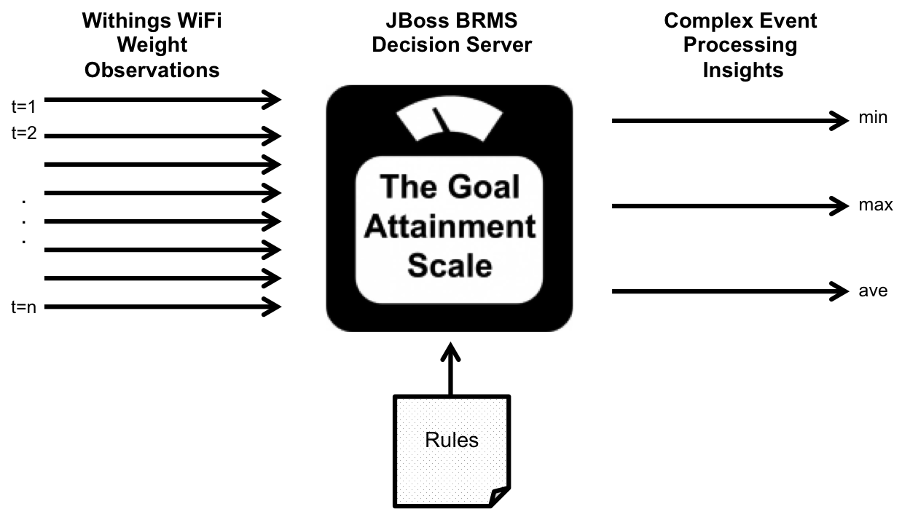

* The Decision Service also goes by the name of KIE Server, Decision Server and Realtime Decision Server

## Learning Goals

We are going to showcase some use cases using the all-in-one Vagrant virtual machine (VM) for OpenShift Origin located at <http://www.openshift.org/vm/> . If you have access to a working OpenShift installation you can omit any setup instructions specific to Vagrant and proceed directly to application setup and use cases.

Note that the OpenShift PaaS provides first class native support for Docker image based container specification and leverages Kubernetes for container (pod) life-cycle management. The learning outcomes of this Demonstration include:

* Install your own OpenShift 3 Vagrant VM
* Install a local DNS service using dnsmasq
* Configure OpenShift 3 to use the local DNS service
* Learn how to pull down Docker images and build new OpenShift applications
* Access the OpenShift locally using URL routes such as *.cloudapps.example.com
* Familiarise yourself with the OpenShift 3 Developer console
* Familiarise yourself with the Drools Work console
* Test out various Drools Decision Service REST APIs using clients such as pHp, RStudio, cURL and SoapUI
* Learn how to change rules using the Workbench and oc rsync the changes to the Decision Service
* A little taste of xPaaS!

## Prerequisites

* Minimum of 4 Mbytes of free available RAM
* Quadcore processor
* At least 10 GBytes of free available disk space
* Vagrant
* Docker Toolbox
* VirtualBox
* MySQL Workbench
* SoapUI

# Setup OpenShift 3

Create a working directory for your demonstration such as ~/Vagrant/OpenShift origin and clone down the main repository for the demo:

https://github.com/StefanoPicozzi/weightwatcher2

## For OpenShift Origin Vagrant VM

Follow these instructions that follow to download, install and prepare the your host with dnsmasq and the guest Vagrant VM. The steps are documented assuming OS/X (El Capitan) and can be summarised as per below.

1. Install the all-in-one VM and make a few changes to overcome a Vagrant ssh timeout issue
2. Setup a dnsmasq service on your host machine
3. Configure your OpenShift Origin VM to reference your dnsmasq service

The setup instructions are currently predominantly manual and OS/X centric - but can be automated and generalised with tools such as Ansible and simplified with the incorporation of a separate VM to host the DNS service. That's on the to-do-list for the Community. The demonstration functions in disconnected (offline) mode subject to notes in Enhancements section.

## For Existing OpenShift System

Proceed directly to section 3.2. Ignore references to Vagrant ssh and users and replace with credentials that represents how you access OpenShift as a Developer and as the root user for system administration purposes.

## dnsmasq Install

// Launch a docker terminal window such as with Docker Toolbox

// Find the <DNS-IP> of your docker shell, e.g. 192.168.99.100

$ docker-machine ls

$ sudo vi /etc/hosts

192.168.33.10 master.example.com openshift

<DNS-IP> dns.example.com dns

127.0.0.1 localhost localhost.localdomain localhost4 localhost4.localdomain4

::1 localhost localhost.localdomain localhost6 localhost6.localdomain6

$ docker pull spicozzi/dnsmasq

$ cd ~

$ git clone https://github.com/StefanoPicozzi/dnsmasq

$ cd dnsmasq

./docker-run.sh

// Set Host to use <DNS-IP> as DNS server

// Desktop Menu > System Preference > Network

// Select your network connection

> Advanced … > DNS

DNS Servers:

// Add <DNS-IP> to top of list

// search Domains:

// Add cloudapps.example.com to top of list

// Check ANSWER SECTION: for 192.168.33.10

$ dig testdrive.cloudapps.example.com

## OpenShift Origin Vagrant Install

$ cd <DEMO-HOME>

// Visit <http://www.openshift.org/vm/> and download all bits to .

$ vagrant box list

$ vagrant box remove openshift3

$ vagrant box add –-name openshift3 openshift-bootstrap*.box

// Follow the website instructions to install the oc client tools

$ oc version

$ vi Vagrantfile

config.vm.network "private_network", ip: "192.168.33.10"

vb.memory = "4096"

// Verify successful boot sequence and su login a few times

$ vagrant up

$ vagrant ssh

$ su –

Password: vagrant

$ vagrant halt

## OpenShift Origin Vagrant Final Preparation Steps

$ cd <DEMO-HOME>

$ vagrant up

$ cd <DEMO-HOME>

$ git clone <https://github.com/StefanoPicozzi/weightwatcher2>

$ vagrant ssh

$ su –

Password: vagrant

$ git clone <https://github.com/StefanoPicozzi/weightwatcher2>

// Edit /etc/resolv.conf and prevent NetworkManager overwrite

// The first nameserver points to your Host <IP> address

# chattr -i /etc/resolv.conf

# vi /etc/resolv.conf

nameserver 192.168.99.100

nameserver 10.0.2.3

# chattr +i /etc/resolv.conf

// Edit /etc/hosts file

# vi /etc/hosts

192.168.33.10 master.example.com openshift

<DNS-IP> dns.example.com dns

127.0.0.1 localhost localhost.localdomain localhost4 localhost4.localdomain4

::1 localhost localhost.localdomain localhost6 localhost6.localdomain6

// Verify ANSWER SECTION: reports 192.168.33.10

# dig testdrive.cloudapps.example.com

# oc get nodes

# Setup Demonstration Applications

Once you have completed these prerequisite OpenShift Origin guest VM and host dnsmasq steps you can move onto setting up the demonstration OpenShift application and use cases. We are going to create three OpenShift (Docker-image-based) applications for the weightwatcher Decision Service, the companion website and another to host RStudio Server. The setup steps are summarised as follows:

1. Verify your environment. Do this every time before you try the demo.
2. Make some configuration changes (as root) to your OpenShift Origin system.
3. Create the applications as a Developer user (as admin)

## Environment Checklist

$ cd ~/dnsmasq

$ ./dnsmasq-run.sh

// Configure Host to use <DNS-IP> as DNS server

$ cd <DEMO-HOME>

$ vagrant status

$ vagrant up

$ ping dns.example.com

$ ping master.example.com

// Should point to <DNS-IP>

$ cat /etc/resolv.conf

// Should match valid external DNS servers, e.g. 8.8.8.8

$ cat ~/resolv.dnsmasq.conf

// Check local DNS correct as ANSWER SECTION: for 192.168.33.10

$ dig testdrive.cloudapps.example.com

// Check external DNS configured correctly

$ ping [www.google.com](http://www.google.com)

## Demo Setup as OpenShift root User

$ cd <DEMO-HOME>

$ vagrant status

$ vagrant up

$ vagrant ssh

Password: vagrant

$ su –

Password: vagrant

# git clone <https://github.com/StefanoPicozzi/weightwatcher2>

# mkdir –p /home/data/mysql

# chmod –R 777 /home/data/mysql

// Check OpenShift security context constraints is RunAsAny

# oc edit scc restricted

# allowHostDirVolumePlugin: true

runAsUser

type: RunAsAny

// Pull down the images

# docker pull openshift/php-55-centos7

# docker pull openshift/mysql-55-centos7

# docker pull spicozzi/weightwatcher2

# docker images

# oc delete project weightwatcher

# oadm new-project weightwatcher --display-name='WeightWatcher' --description='WeightWatcher Decision Service Demonstration' --admin=admin

# oc project weightwatcher

# oc create –f weightwatcher2/src/testdrive/php-55.json

# oc get images

# Standard Use Cases

## OpenShift Developer Console Tour

Open your browser at the address of the OpenShift Developer application – <https://master.example.com:8443>. Tour around the application and try out some of the features such as inspecting the log files of a running pod and logging into a container.

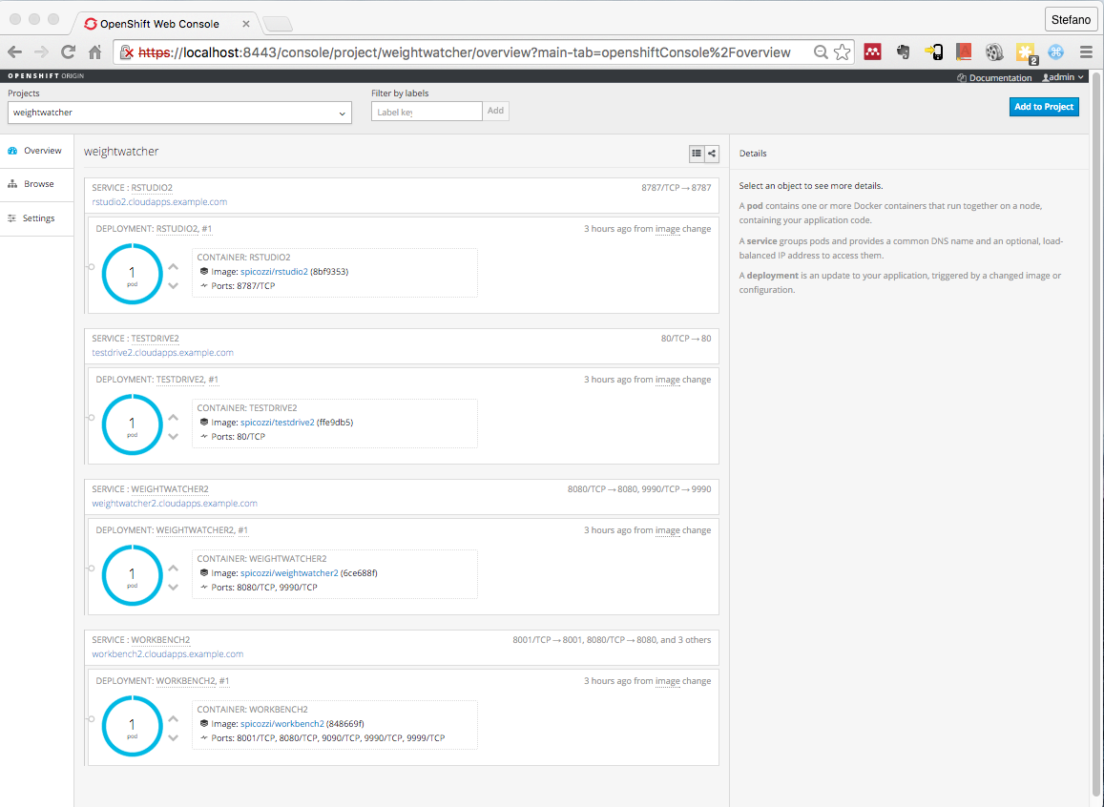

## Docker Image to Create Decision Service

Here we will create the Decision Service based on an existing Docker image. These samples assumes you have cloned down https://github.com/StefanoPicozzi/weightwatcher2 . Some simple cURL scripts have also been supplied to test the health of your configuration are located under the /tools/cURL. These are similar to the test cases available at the companion website and assume weightwatcher.cloudapps.example.com as the Decision Service endpoint. Edit each script to change the http://FQDN:PORT if necessary:

$ cd <DEMO-HOME>

$ oc login

Username: admin

Password: password

$ oc delete all –l name=weightwatcher

$ oc new-app spicozzi/weightwatcher2 –-name=weightwatcher –l name=weightwatcher

// Assign a route

$ oc get svc

$ oc expose service weightwatcher --name=weightwatcher -l name=weightwatcher --hostname=weightwatcher.cloudapps.example.com

$ oc status

$ oc get all –l name=weightwatcher

$ oc get dc –o json

$ cd tools/cURL

// Smoke test the new app

$ oc scale --replicas=5 dc weightwatcher

$ ./post-facts.sh

$ oc scale --replicas=3 dc weightwatcher

$ ./post-facts.sh

$ oc scale --replicas=1 dc weightwatcher

$ ./post-facts.sh

## Source To Image to Create Companion Website

Here we will create a companion website using the source to image feature.

$ cd <DEMO-HOME>

// Create and note the location of a fork of the Git repo at <https://github.com/StefanoPicozzi/testdrive>

$ oc delete all -l name=testdrive

// Create the app using the CLI or Console using your forked GitHub

$ oc new-app openshift/php-55-centos7~https://github.com/StefanoPicozzi/testdrive --name=testdrive -l name=testdrive strategy=source

$ oc get builds

$ oc build-logs <NAME> -f

// Assign a route

$ oc expose service testdrive --name=testdrive -l name=testdrive --hostname=testdrive.cloudapps.example.com

// Explore the new app

$ oc status testdrive

$ oc get all –l name=testdrive

$ oc describe bc testdrive

$ oc edit bc testdrive -o json

Open your browser at the address of the PHP companion application – testdrive.cloudapps.example.com. This showcases some of the many Decision Service REST APIs.

Set the FQDN:PORT to point to your Decision Service instance which defaults to weightwatcher.cloudapps.example.com and click Submit to save. Now try the Post Facts menu option to verify that it is accepting requests correctly. Output should look similar to the below in the side-by-side screen shots. The other choices refer to other optional Decision Service API features and test cases that are documented separately.

|  |  |
| --- | --- |
| Macintosh HD:Users:stefanopicozzi:Desktop:Screen Shot 2015-11-23 at 4.28.47 PM.png | Macintosh HD:Users:stefanopicozzi:Desktop:Screen Shot 2015-11-23 at 4.29.43 PM.png |

## Drools Workbench Tour

The demonstration stands up the Drools Workbench so you can use the Console to edit and create rule. First we need to build our Workbench application on OpenShift.

# cd <DEMO-HOME>

# cd weightwatcher2/src/workbench

# docker build -t spicozzi/workbench .

$ cd <DEMO-HOME>

$ cd weightwatcher/src/workbench

$ oc delete all –l name=workbench

$ oc create -f workbench.yaml

// Assign a route

$ oc get svc

$ oc expose service workbench --name=workbench -l name=workbench --hostname=workbench.cloudapps.example.com

$ oc status

$ oc get all –l name=workbench

$ oc get builds

Now open your browser at the address of the Drools Workbench – [workbench.cloudapps.example.com/drools-wb](https://master.example.com:8443) - and login as admin/admin. Tour around the application and try out some of the features such as inspecting the supplied project, DRL files and Data Models. You may use this later if you wish to change some of the rules and apply the changes to the Decision Service.

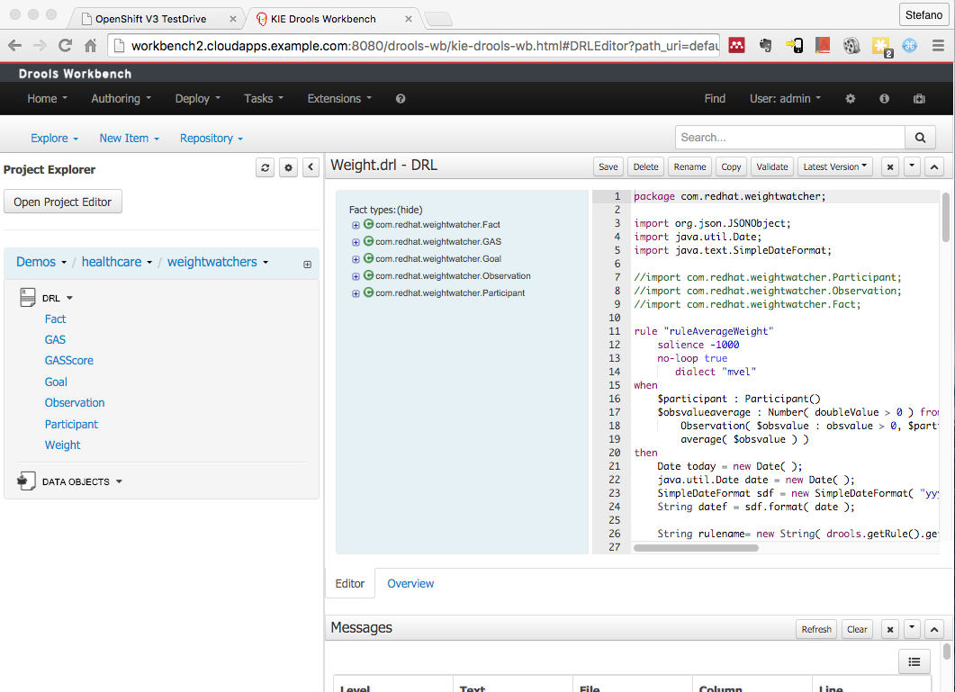

## SoapUI Samples

These samples assumes you have SoapUI installed on your workstation and that you have cloned down https://github.com/StefanoPicozzi/weightwatcher2 . Launch SoapUI and then import the project with a name that includes the label "Business APs" as located at weightwatcher2/tools/SoapUI. The 3 supplied resources and REST POST requests are samples representing the following.

"Facts" shows a simple request in which a request payload of facts are *inserted* into the Decision Service knowledge base and then a *query* is issued to verify this action has been successful.

The "Weight Watch" sample shows an invocation in which a set of facts containing weight measurements is sent to the Decision Service. CEP rules are then applied to derive insights as per the response payload. The request consists of facts representing Participant, Goal and Observation data records. The Participant records capture details of the user, Goal captures the Participant's target weight objectives and Observation records a time series of weight measurements. The response payload then returns a set of facts reporting minimum, maximum and weight change statistics over a sliding time window.

The "Goal Attainment" sample demonstrates a use case in which the Participant has elected to enter into a period of intermittent fasting, known as the Fast Diet <http://thefastdiet.co.uk/>. The GAS fact represents the Participant's number of fasting day goals over the week, described in ranges of worst through to best outcomes, refer <http://en.wikipedia.org/wiki/Goal_Attainment_Scaling> for details on the method. The Observation records then report back actual days of fasting in the previous weeks. The Decision Service then responds back with performance against goals. The GAS fact table is a candidate for remodelling using, e.g. a Guided Decision Tables.

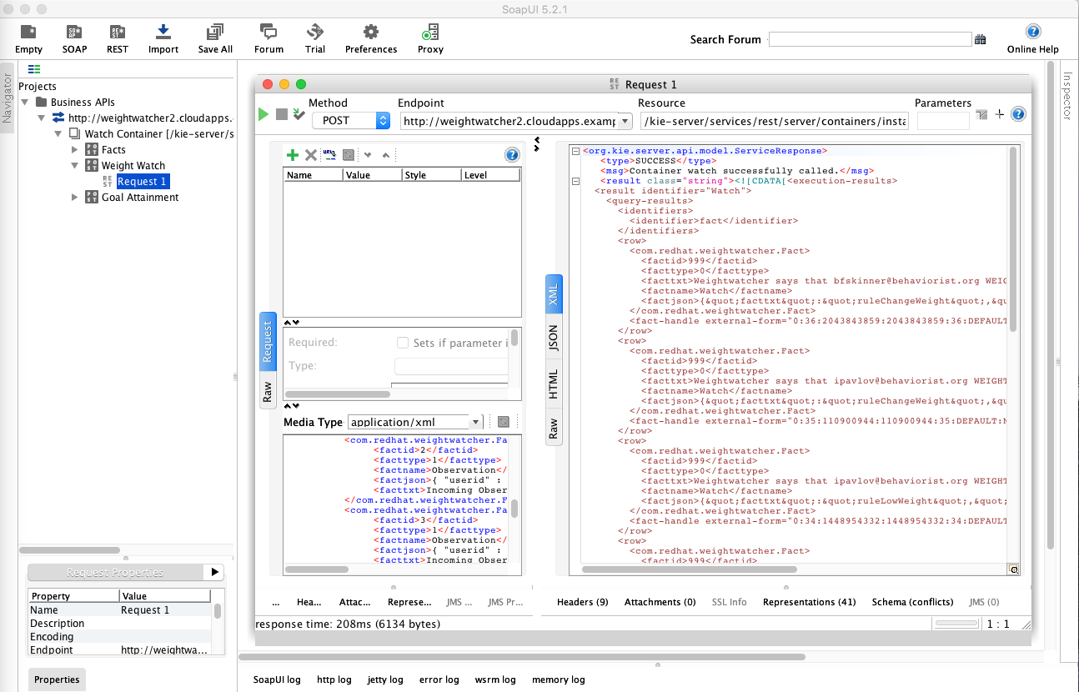

## R using RStudio

The demonstration shows R script using RStudio Server as a client interacting with the Decision Service. First we need to build our RStudio Server application on OpenShift.

# cd <DEMO-HOME>

# oc get images -n openshift | grep rstudio

# oc delete image -n openshift <NAME>

# cd weightwatcher2/src/rstudio

# docker build -t spicozzi/rstudio .

$ cd <DEMO-HOME>

$ oc delete all –l name=rstudio

$ oc create -f rstudio.json

$ oc expose service rstudio --name=rstudio -l name=rstudio --hostname=rstudio.cloudapps.example.com

$ oc status

$ oc get all –l name=rstudio

Launch the RStudio pod – rstudio.cloudapps.example.com. Login as guest/guest. Edit the weightwatcher.R script URL end point to reflect your environment if necessary, then source to run. Inspect the R script for hints of techniques on how to prepare, send and receive payloads between R and the Decision Service.

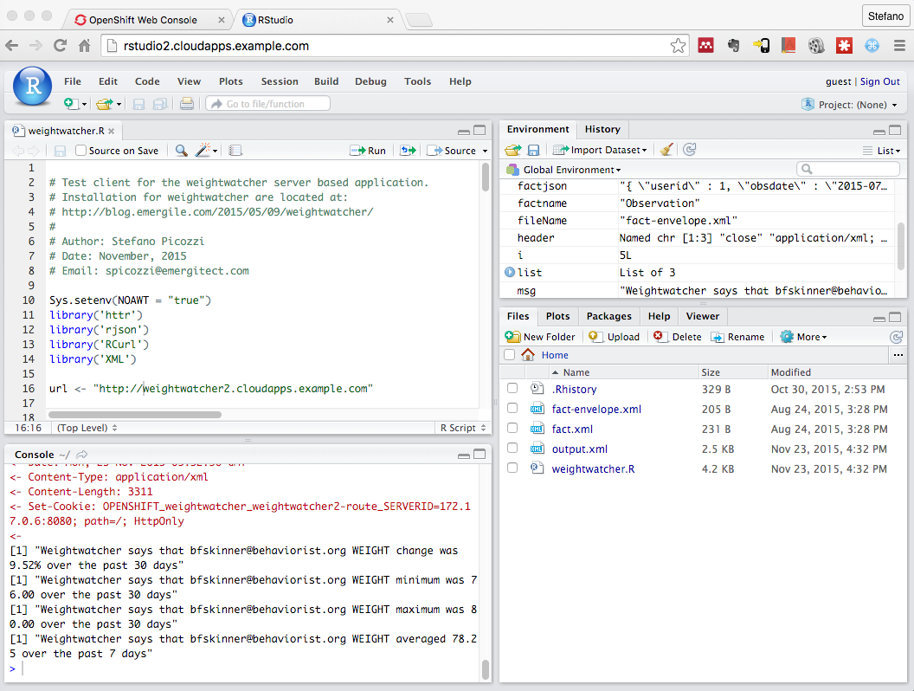

// Now that you've finished with rstudio why not scale it down to zero

$ oc scale --replicas=0 dc rstudio

// To restore the rstudio pod scale it up to one

$ oc scale --replicas=1 dc rstudio

# Advanced Use Cases

## MySQL with Persistent Storage

Here we will create a MySQL database with persistent storage using the hostPath method. For some alternate approaches such as using NFS refer:

* $ oc create -f https://raw.githubusercontent.com/openshift/origin/master/examples/db-templates/mysql-persistent-template.json
* <https://github.com/openshift/origin/tree/master/examples/wordpress/nfs>

$ cd <DEMO-HOME>

$ cd weightwatcher2/src/mysql

$ oc delete –f mysql/mysql-55.json

$ oc create –f mysql/mysql-55.json

$ oc get imageStreams

$ oc delete all –l name=mysql

$ oc create –f mysql-persistent-template.json --name=mysql -l name=mysql

$ oc get all –l name=mysql

$ oc env pod/mysql --list

$ oc get service mysql

$ oc expose service mysql --name=mysql -l name=mysql --hostname=mysql.cloudapps.example.com

$ oc port-forward mysql 3307:3306

// Now launch a tool such as MySQL Workbench and point to the database

## Rule Changes using oc rsync

A more advanced rule change use case is also documented later that makes use of the OpenShift (oc) rsync feature. Basic schematic as follows. Refer also <http://blog.emergile.com/2015/11/16/drools-rules-rsynchronicity/>

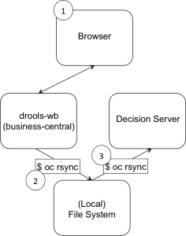

### Start the Decision Service Scanner

// This is necessary so that the Decision Service will pick up rule changes

// Launch a Browser and point it to testdrive.cloudapps.example.com

// Click the Start Watch Scanner menu option

// Click the Get Watch Scanner menu option to verify

### Rule Changes using Workbench

// Launch a Browser to workbench.cloudapps.example.com/drools-wb

// Login as admin/admin

// Use the workbench GUI to make some changes to a DRL file

// Click build & deploy to save the changes to the rules .jar file

$ cd ~/Vagrant/OpenShift

// Now oc rync the repository directory to your local file system

// First find the NAME of the pod

$ oc get pods | grep workbench2

// Now pull down the rules repo

$ oc rsync <NAME>:/opt/jboss/.m2/repository .

### Apply Rule Changes to the Decision Service

// Now rynch the local repository directory up to the weightwatcher2 pod

$ cd <DEMO-HOME>

// First find the NAME of the pod

$ oc get pods | grep weightwatcher2

// Now push up the rules repo

$ oc rsync repository <NAME>:/opt/jboss/.m2

// Check that the scanner has picked up the changed rules file

$ oc logs –f <NAME>

// Launch a Browser and point it to testdrive.cloudapps.example.com

// Click the Post Facts menu option to verify changes applied

$ oc logs –f <NAME>

# Extras

## Image Download

The runtime artefacts for this demonstration application have all been packaged up according to the Docker container specification. The various Docker images can be downloaded directly as follows:

|  |
| --- |
| # The Decision Service as a Docker image  $ docker pull spicozzi/weightwatcher2  # A companion PHP website with test cases  $ docker pull spicozzi/testdrive2  # An optional RStudio Server image with R test case included  $ docker pull spicozzi/rstudio2  # An optional JBoss Drools workbench image used for rule changing use case  $ docker pull spicozzi/workbench2 |

## Source Download

Repositories containing source code, content and support files related to the three images listed above can be inspected as per the GitHub links below.

|  |
| --- |
| https://github.com/StefanoPicozzi/weightwatcher2  https://github.com/StefanoPicozzi/testdrive2  https://github.com/StefanoPicozzi/RStudio2  https://github.com/StefanoPicozzi/workbench2 |

## Launch Container Instances using Docker Toolbox

You can run launch these images directly from Docker as follows.

# Launch 4 terminal windows and run the container instances in each

# Find the IP_ADDRESS used by your instances, e.g.

$ docker-machine ls

# Terminal 1

$ docker run -it -p 81:80 spicozzi/testdrive2

# Terminal 2

$ docker run -it -p 8080:8080 spicozzi/weightwatcher2

# Terminal 3 (optional)

$ docker run -it -p 8087:8087 spicozzi/rstudio2

# Terminal 4 (optional)

$ docker run -it -p 8081:8080 spicozzi/workbench2

## Useful (Docker Toolbox) Docker Commands

|  |
| --- |
| # Find <IP> of Docker virtual machine  $ docker-machine ls  # List of docker images  $ docker images  # List of running docker containers showing <CONTAINER_ID>  $ docker ps –l  $ docker attach <CONTAINER_ID>  # Kill a running docker container with <CONTAINER_ID>  $ docker rm –f <CONTAINER_ID>  # Pull down a docker image  $ docker pull spicozzi/nginx  # Disconnected access to load Docker images  $ docker save -o workbench2.tar spicozzi/workbench2  $ docker load –i workbench2.tar  # Commit changes in a running Container as an image  # From another terminal get the <CONTAINER_ID>  $ docker ps -l  $ docker commit <CONTAINER_ID> spicozzi/nginx  # Assume you have a running container named weightwatcher1  $ docker logs -f weightwatcher1  $ docker rm -f weightwatcher1  # Remove all running containers  $ docker rm -f $(docker ps -aq)  # Remove all untagged images  $ docker rmi -f $(docker images | grep "<none>" | awk "{print $3}") |

## Useful OpenShift Commands

// Explanation of OpenShift concepts

$ oc types

// To scale up replicas

$ oc scale dc weightwatcher2 --replicas=2

// Tail the log file for the created pod

$ oc get pods

$ oc logs –f <PODNAME>

// If you make any errors just delete the <PROJECT> and repeat

$ oc delete project <PROJECT>

// Find the openshift configuration <CONFIG>

# locate master-config

# openshift ex validate master-config <CONFIG>

// Stop/start openshift

# systemctl stop openshift

# systemctl start openshift

# systemctl status openshift

# journalctl -f -u openshift-master

# journalctl -f -u openshift-node

## Useful Vagrant Commands

$ vagrant box remove –f openshift3

# Create image off existing box

$ mkdir <DEMO-HOME>

$ cd <DEMO-HOME>

$ vagrant package –-output ../weightwatcher/weightwatcher.box

$ cp Vagrantfile ../weightwatcher

$ cd ~/Vagrant/weightwatcher

$ vi Vagrantfile

:1,$ s/openshift3/weightwatcher/g

$ vagrant box add weightwatcher weightwatcher.box

## Changing Rules Docker Toolbox example

This demonstration shows a use case in which rule are changed using the JBoss Business Central studio and then those changes reflected in the Decision Service directly from Docker as tested using Docker Toolbox on OS/X. The basic steps are as follows:

1. (Re)launch the JBoss Drools Workbench container (workbench2) with the Maven repository mounted as an external volume (workbench2/m2)
2. (Re)launch the Decision Service container (weightwatcher2) with the Maven repository mounted as an external volume (weightwatcher2/m2)
3. (Re)launch the companion website PHP application (testdrive2)
4. From testdrive2 Browser, click Start Scanner to start the Decision Service scanner
5. From workbench2 Workbench Browser, make some changes to your rules, save them and then build-and-deploy the artefact. Login to Workbench using IP_ADDRESS:8018/drools-wb and credentials admin/admin
6. From the workbench/m2 file system, copy all the contents in com/redhat/demos/weightwatchers/1.0 to your clipboard
7. From the weightwatcher2/m2 file system, paste the clipboard contents to com/redhat/demos/weightwatchers/1.0
8. From testdrive2 Browser, click Post Facts and verify that the changes have been applied
9. From workbench2 container window, check the log for evidence of a change to the rule jar file
10. From weightwatcher2 container window, check the log for evidence of a scanner event to for a new rule jar file

For steps 1 and 2, check the sample Docker launch scripts supplied at the GitHub repository for examples on how to approach the volume attachment requirement. These instructions assume familiarity with authoring rules using Drools Workbench. Steps 6 and 7 can be automated for more real-life scenarios using your, e.g. favourite CI/CD tooling.

## Quick Restart Checklist

* From host operating system
  + Start dnsmasq Docker container
  + Start vagrant OpenShift box
* From Network Preferences
  + Note down the DNS servers supplied by your Network provider
  + Edit the DNS Server to be <DNS-IP> of your dnsmasq server
  + Verify Search domains contains cloudapps.example.com
* From host operating system
  + Edit ~/dnsmasq/dnsmasq.resolv.conf to use external DNS servers noted above
  + Verify with dig testdrive.cloudapps.example.com
  + Ping master.example.com, dns.example.com
* From guest operating system
  + vagrant ssh
  + su –
  + Verify with dig testdrive.cloudapps.example.com
  + Ping master.example.com, dns.example.com

# Enhancements

## To Do

* Cross-platform automation of configuration steps for IP addressing
* Offline/disconnected mode operation
  + For later Mac OS/X, virtual Ethernet mapping is a problem issues can be resolved by attaching a loopback Ethernet jack or equivalent (e.g. an ISP dongle)

* Use case for JBoss Developer Studio integration via oc port-forward
* Application of oc import-image to import images
* Demonstrate oc scale usage for weightwatcher2
* Add tags to images
* OpenShift image management tips and tricks
* Add EFK log aggregation and heapster for metrics capture
* Port to OpenShift Enterprise and JBoss BRMS as available
* Integrating external service endpoint with service object for FitBit or MySQL example
* m2 repository as common external localvol for workbench and weightwatcher pods
* Jenkins integration